

FUNCTIONAL DESIGN
INTEGRATION

Payment Advice
​​​​
Table of Contents
1 Document History 6
1.1 Standard Information 6
1.2 Change History 7
1.3 Approval Details 7
1.4 Other Related Documents 7
1.5 RASCI 7
2 Functional Overview 7
2.1 Functional Summary 8
2.2 Functional Requirements 8
2.3 Reason and Business Purposes 8
2.4 In/Out of Scope 8
2.6 Dependencies and Constraints 8
2.7 Risks and Issues 8
2.7.0 Risks 8
2.7.1 Issues 8
3 Functional Design 9
3.1 Functional Design Overview 9
3.2 Existing process 9
3.3 Sub Process Flow and Activity 9
3.4 Necessary SAP Standard Configuration 9
3.5 Define Use Case / test case. 10
3.6 Detailed Requirement 10
3.6.1 Initiating/Triggering Process 11
3.6.2 Detailed field mapping 11
3.6.3 Input files/data samples 13
3.6.4 Custom tables 13
3.7 Integration Directory 13
3.7.2 Deployment Model 13
3.7.3 Potential Failure Points & Reconciliation 14
3.7.4 Retry Logic 14
3.7.5 Business rules 14
3.7.6 Control, filtering, Validation 14
3.7.7 Outbound and Inbound Logic 14
3.8 Other Considerations 14
3.8.1 Selection Screen 14
3.8.2 Frequency and Timing 15
3.8.3 Batch job details 15
3.8.4 Transaction volumes 15
3.8.5 Security requirements 15
3.8.6 Language and translation requirements 15
3.8.7 Performance considerations 15
3.8.8 Non-functional requirements 15
4 Testing 15
4.1 Unit Test 16
5 Appendix 16
5.1 Glossary of Terms 16
5.2 Additional Supporting/Reference Documentation 16
6 Miscellaneous 16
7 References 16

​
​
​
​
​
​
​
​
​
​
​
​
​
​
​
​
​
​
​
​
​
​
​
​
​
​
​
​
​
​
​
​
​
​
​
​
​
​
​
​
​
​
​
​
​
​
​
​
​
​

​
​
​
​
​
​
​
​
​
​
​
​
​
​
​
​
​
​
​
​
​
​
​
​
​
​
​
​
​
​
​
​
​
​
​
​
​
​
​
​
​
​
​
​
​
​
​
​
​
​

1 Document History

1.1 Standard Information
RICEFW Log ID
Type of Development | Report
Naming Convention
Team | New Code Generation
Transport Request Numbers & Description
Type of Transport
Abbreviations and Definitions
Related Epics and Capabilities/ Process Hierarchy Node
Geographies Impacted
Priority
Complexity | Medium
Release | Sprint 4
Authorization development
Source
Disposition
Business Justification
Capacity to leverage
Rationalization decision
Comments

1.2 Change History
Ver. | Date | Summary of Changes | Author | Transport Number

1.3 Approval Details
Review No. | Date | Name of Approver | Signature
 | 28.12.2023 | Tannaz Shaheen Ahmed

1.4 Other Related Documents
Related Documents | Comments

1.5 RASCI
RASCI | Role | Name | Contact

2 Functional Overview
No matching content is available for this section.

2.1 Functional Summary
This error is displayed where some error is found during update in OB08 transaction. The error detail, with standard error messages, must be described in e-mail that will be sending to responsible.
To solve this problem, check the OB08 and Product configuration and values that were received from Flat File.

2.2 Functional Requirements
To send the status of invoice to vendors/suppliers, payment advice will be used. This will serve as the proof of received payment.

2.3 Reason and Business Purposes
No matching content is available for this section.

2.4 In/Out of Scope

2.6 Dependencies and Constraints
- A Payment advice is a notice of a payment to be made.
- A Payment advice may cover one or more commercial trade transactions (and related financial
transactions), such as invoices, credit notes, debit notes, etc.
- A Payment advice may include a cross reference to a Payment Order.
- A single Payment advice may relate to both national and international settlements.
- Each Payment advice shall be calculated in only one currency, even though the related transaction is denominated in different currencies.
- Each Payment advice shall relate to only one settlement date.
- Either SAP User login language or vendor master communication language will derive the language in which Remittance Form will be generated.
Client will ensure that a variant of the standard SAP program or custom program is created in the system to conform to the Client format requirements.

2.7 Risks and Issues
N/A

2.7.0 Risks
Risk Log ID | Description | Migration Plan

2.7.1 Issues
Issue Log ID | Description | Remarks

3 Functional Design

3.1 Functional Design Overview
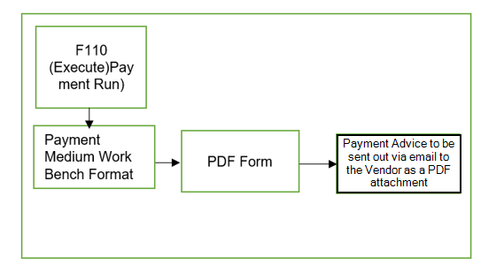
Process Inputs
Transaction: F110 and FBZ5.
Process Flow for generating the Payment Advice output:
- AP Processor will execute the Proposal run for open invoices based on parameters given in F110.
- Proposal run will be executed.
- Proposal generated by the system based on the parameters will be /can be edited by the AP processor.
- Payment run will be executed.
- On successful execution of the payment run, the payment will be processed, and the Payment output will be generated in PDF format and will be sent out via email to the vendor.
- In case if the vendor email id is not maintained in the vendor master, the payment advice will only be generated as a spool and will not be sent in a mail. To trace if the mail was sent or not, the user can logon to the common mailbox maintained based on company code.

3.2 Existing process

3.3 Sub Process Flow and Activity

3.4 Necessary SAP Standard Configuration

3.5 Define Use Case / test case.
Use case | Test Case | Test Scenario | Process Hierarchy

3.6 Detailed Requirement
Driver Program and Format Details

Main Heading | The title Payment advice should appear on each page of the document. Additionally, the page numbering should also appear on each page.
Sub Heading
Totaling
Page Breaks | Based on the page breaks above a new Payment advice should be created for each change of currency within a vendor and above this for each change of vendor within the company code. Implicitly this defines a new page break.  If the number of line items exceed page capacity a new page with line item details along with column heading should be printed in the new page.
Report Paper Size | A4 Size Paper
Color Definition
Sort Sequence | The form should be sorted by company code, vendor and currency. A new Payment advice should be created for each change of currency within a vendor and above this for each change of vendor within the company code
Stationery | Current default settings for output device as provided by SAP for each region should be same. The default settings will be used to print form.
Barcode | NA
Output Type (Mail/Fax/Print) | Email : Please see the details below

Sender email id | Sender Email Id will be determined based on the company code. Refer the list below.
CC Email id | The Sender Email Id will be copied in the CC as well. This will  - The user in checking if the Payment Advice mail was sent  - This will help in not exposing the user email id to the vendor.
Recipient Email id | Vendor’s email id Fetched from the Vendor’s Master data. (LFB1-INTAD)
Email Subject: | Payment Advice
Email Text: | Dear Valued Vendor,  Attached file contains the remittance information of payment made to you  For any questions, Please advise in case of any query to the Accounts  Payable Customer Service Team below dependent on your business and  location.  North America: QuestionsAP@XXXXX.com  Europe: QuestionsAP@XXXXX.com  South America: ConsultAP@XXXXXX.com  AEMEA: XXXXXXAP@XXXXXX.com  Regards  Accounts Payable Team

3.6.1 Initiating/Triggering Process

3.6.2 Detailed field mapping

Form Fields
Form Field mapping
7Field No | Source Table | Source Field Name | Source Technical Field Name | Max Output Length | Notes
1 | ADRC- NAME1 | Name 1 | Name 1 | 40 | N/A
2 | ADRC-STREET | Street | Street | 10 | N/A
3 | ADRC- City1 | City | City | 40 | N/A
4 | ADRC-REGION | Region | Region | 3
5 | ADRC- POST_CODE1 | City postal code | City postal code | 10 | N/A
6 | ADRC- TEL_NUMBER | First telephone no.: dialling code+number | First telephone no.: dialling code+number | 30 | N/A
7 | REGUH-LAUFD | Date on Which the Program Is to Be Run | Date on Which the Program Is to Be Run | 8 | N/A
8 | REGUP-VBLNR | Document Number of the Payment Document | Document Number of the Payment Document | 10 | N/A
9 | REGUH-LAUFD | Date on Which the Program Is to Be Run | Date on Which the Program Is to Be Run | 8 | N/A
10 | TO be picked from TVRAVC |  |  |  | To be picked upon the entries of TVARVC table. Currently approval is pending for the same.
11 | REGUH-LIFNR | Account Number of Vendor or Creditor | Account Number of Vendor or Creditor | 10 | N/A
12 | REGUH-EIKTO | Account at customer | Account at customer | 12 | N/A
13 | REGUH-LAUFD | Date on Which the Program Is to Be Run | Date on Which the Program Is to Be Run | 8 | Same as 5
14 | REGUP- XBLNR | Reference Document Number | Reference Document Number | 16 | Reference No. Column
15 | REGUP-BELNR | Document Number of the Invoice Document | Document Number of the AP Invoice Document | 10 | Your Invoice No. Column
16 | REGUP- BLDAT | Document Date in Document | Document Date in Document | 8 | Inv. Date Column
17 | REGUP- WAERS | Currency | Currency Key | 3 | N/A
18 | REGUP- WSKTO | Cash discount amount in document currency | Cash discount amount in document currency | 13 | Discount Column
19 | REGUP-WRBTR | Amount in document currency | Amount in document currency | 13 | Gross Amount Column
20 | REGUH -ZNME1 | Name of the payee | Name of the payee | 35 | N/A
21 | REGUH -ZPFAC | P.O. box of the payee | P.O. box of the payee | 10 | N/A
22 | REGUH –ZORT1 | City of the payee | City of the payee | 35 | N/A
23 | REGUH -ZREGI | Regional code of the payee | Regional code of the payee | 3 | N/A
24 | REGUH -ZPSTL | Postal code of the payee | Postal code of the payee | 10 | N/A
25 | REGUH – ZBNKN | Bank no. Of the Vendor | Bank no. Of the Vendor | 18 | Display only last 4 Digits.

3.6.3 Input files/data samples
Input file / data sample name | File attachment / link

3.6.4 Custom tables

3.7 Integration Directory

3.7.2 Deployment Model

3.7.3 Potential Failure Points & Reconciliation
In case the payment advice is not triggered, the user needs to check the job log for the payment run and make the necessary changes. Once the changes are done, the user needs to retrigger the job from the payment run.

3.7.4 Retry Logic

3.7.5 Business rules

3.7.6 Control, filtering, Validation

3.7.7 Outbound and Inbound Logic

3.8 Other Considerations

3.8.1 Selection Screen
Report or Form Layout
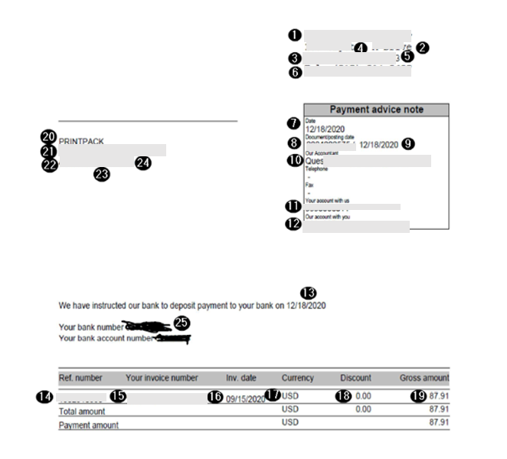



3.8.2 Frequency and Timing

3.8.3 Batch job details

3.8.4 Transaction volumes

3.8.5 Security requirements

3.8.6 Language and translation requirements

3.8.7 Performance considerations

3.8.8 Non-functional requirements

4 Testing

4.1 Unit Test

5 Appendix
No matching content is available for this section.

5.1 Glossary of Terms
No matching content is available for this section.

5.2 Additional Supporting/Reference Documentation
No matching content is available for this section.

6 Miscellaneous

7 References

